Human Capital Management (HCM I)

Step 1: Create Positions

Submit the screen shot showing the staff assignments (5 points)

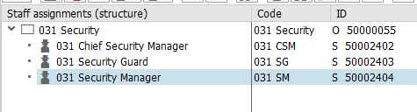

Step 2: Create Career

Submit the screen shot showing the above tree (5 points).

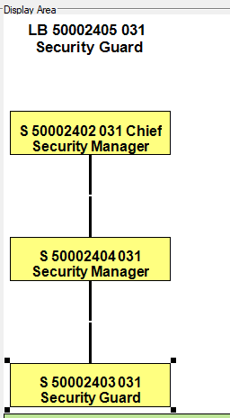

Step 3: Define Requirements

Submit the screen shot showing the requirements (2.5 points)

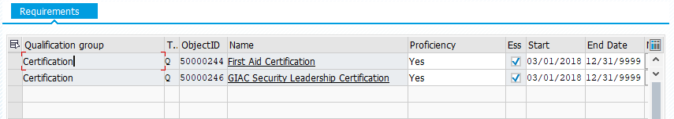

Step 4: HireEmployee

**Write down the Personnel Number of your employee, stated at the top of the screen in the field Personnel No.**

**133**

Step 5: Display Organizational Plan

Submit the staff assignments screen showing the employee you have added (5 points)

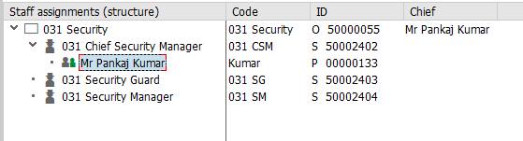

Step 6: Post Job Advertisement

Submit the screen shot of Choose vacancies (2.5 points).

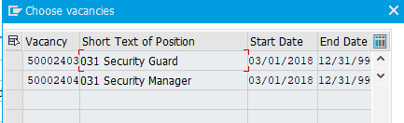

Step 7: Enter Applicant Master Data

Submit the Create Addresses screen shot (2.5 points)

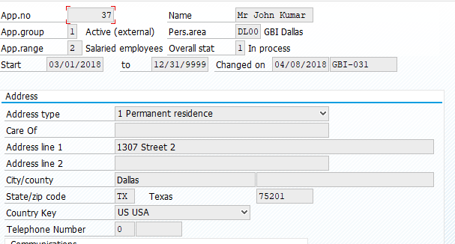

write down the applicant number displayed by the system in the status bar.

Copy Applicant number: ____37_____

Step 8: Prepare Hiring

No screenshot required.

Step 9: Hiring Applicant

Write down the new personnel number.

135

Submit screen shot of Create Action screen (2.5 points).

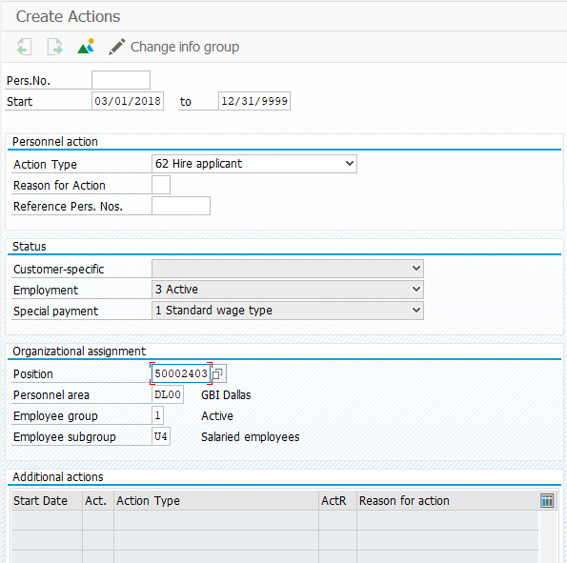

Step 10: Proof Hiring

Submit the screen shot of Staff assignments structure showing the new employee hired (2.5 points).

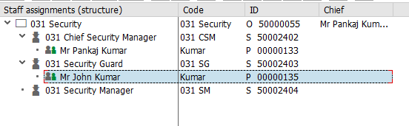

Step 11: Maintain Qualification Profile

Submit the profile screen of the new employee added showing the certification (2.5 points)

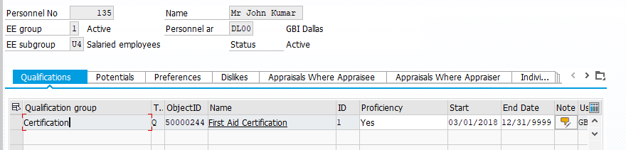

Step 12: Execute Career Planning

Submit the screenshot of the above profile matchup screen (2.5 points).

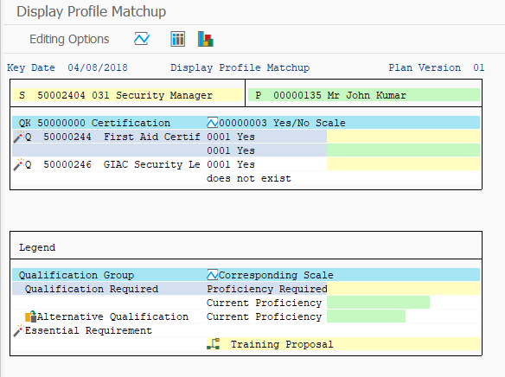

Step 13: Create an event

Submit the screen shot of the dynamic business event menu (2.5 points).

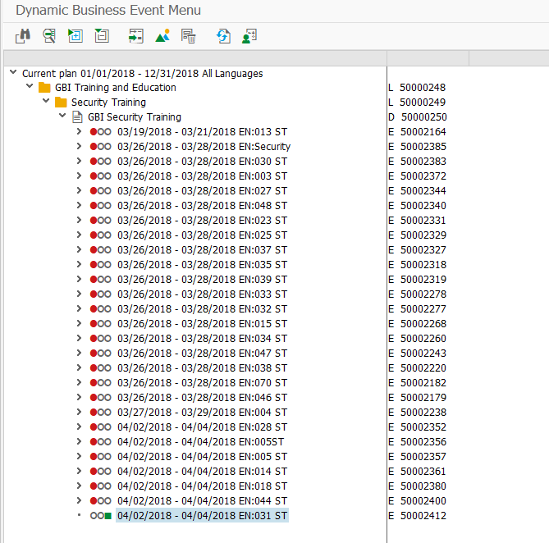

Step 14: Book the event

Submit the GBI Security Training screen showing the employee added (2.5 points)

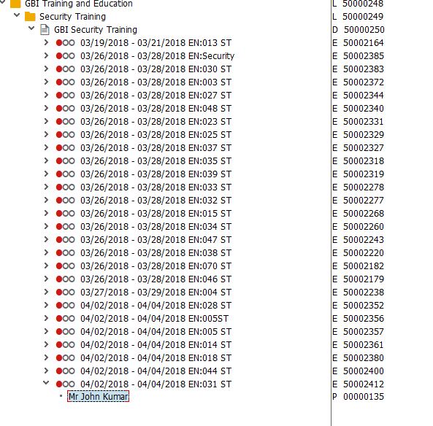

Step 15: Follow up the event

Submit the screenshot of Follow Up Business Event: Qualifications and Actions Screen (2.5 points).

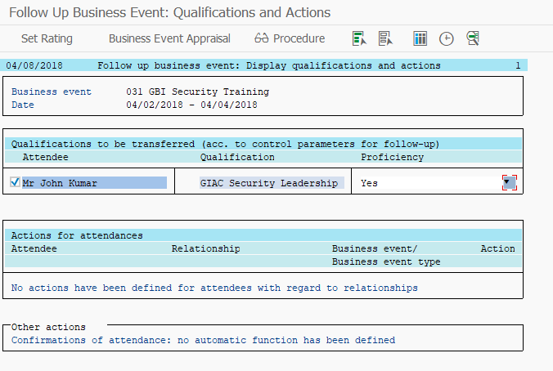

Step 16: Execute Career Planning

Submit the screen shot of Display Profile Matchup screen (2.5 points).

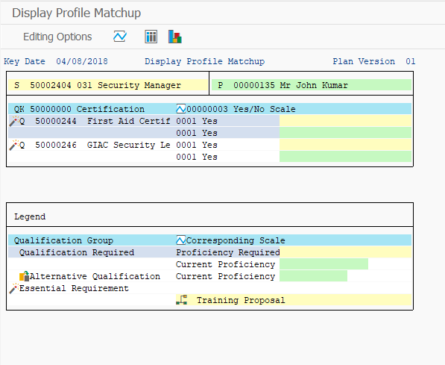

Step 17: Prepare Appraisal

Submit the screenshot of Generate To-Do List screen (2.5 points)

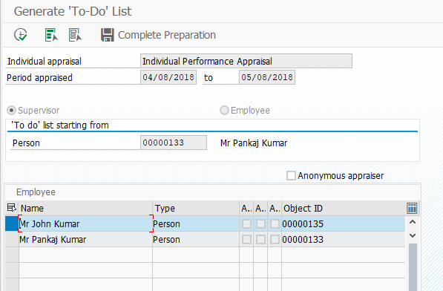

Step 18: Perform Appraisal

Submit the screen shot of the Edit Appraisals screen (2.5 points).

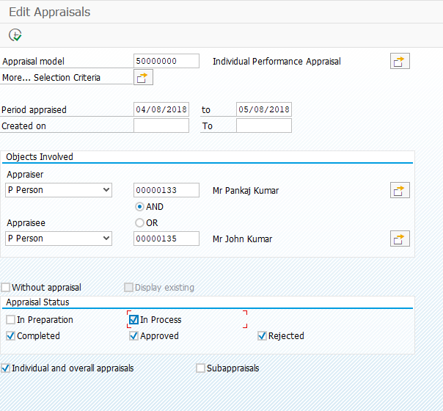

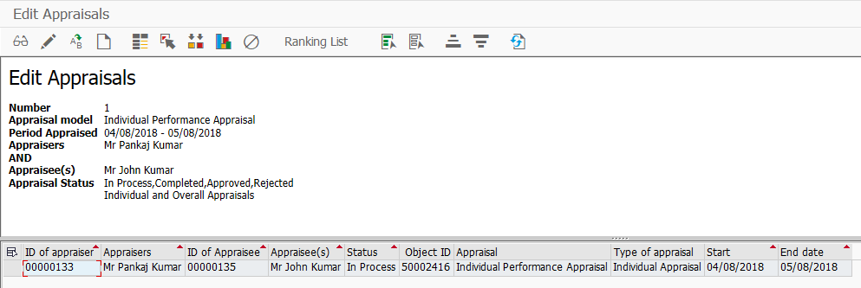

Step 19: Transfer of Employee

Submit the screen shot of the staff assignment structure screen (2.5 points).

